Material #1 - 7mm thick　天然スポンジゴム (natural sponge rubber)

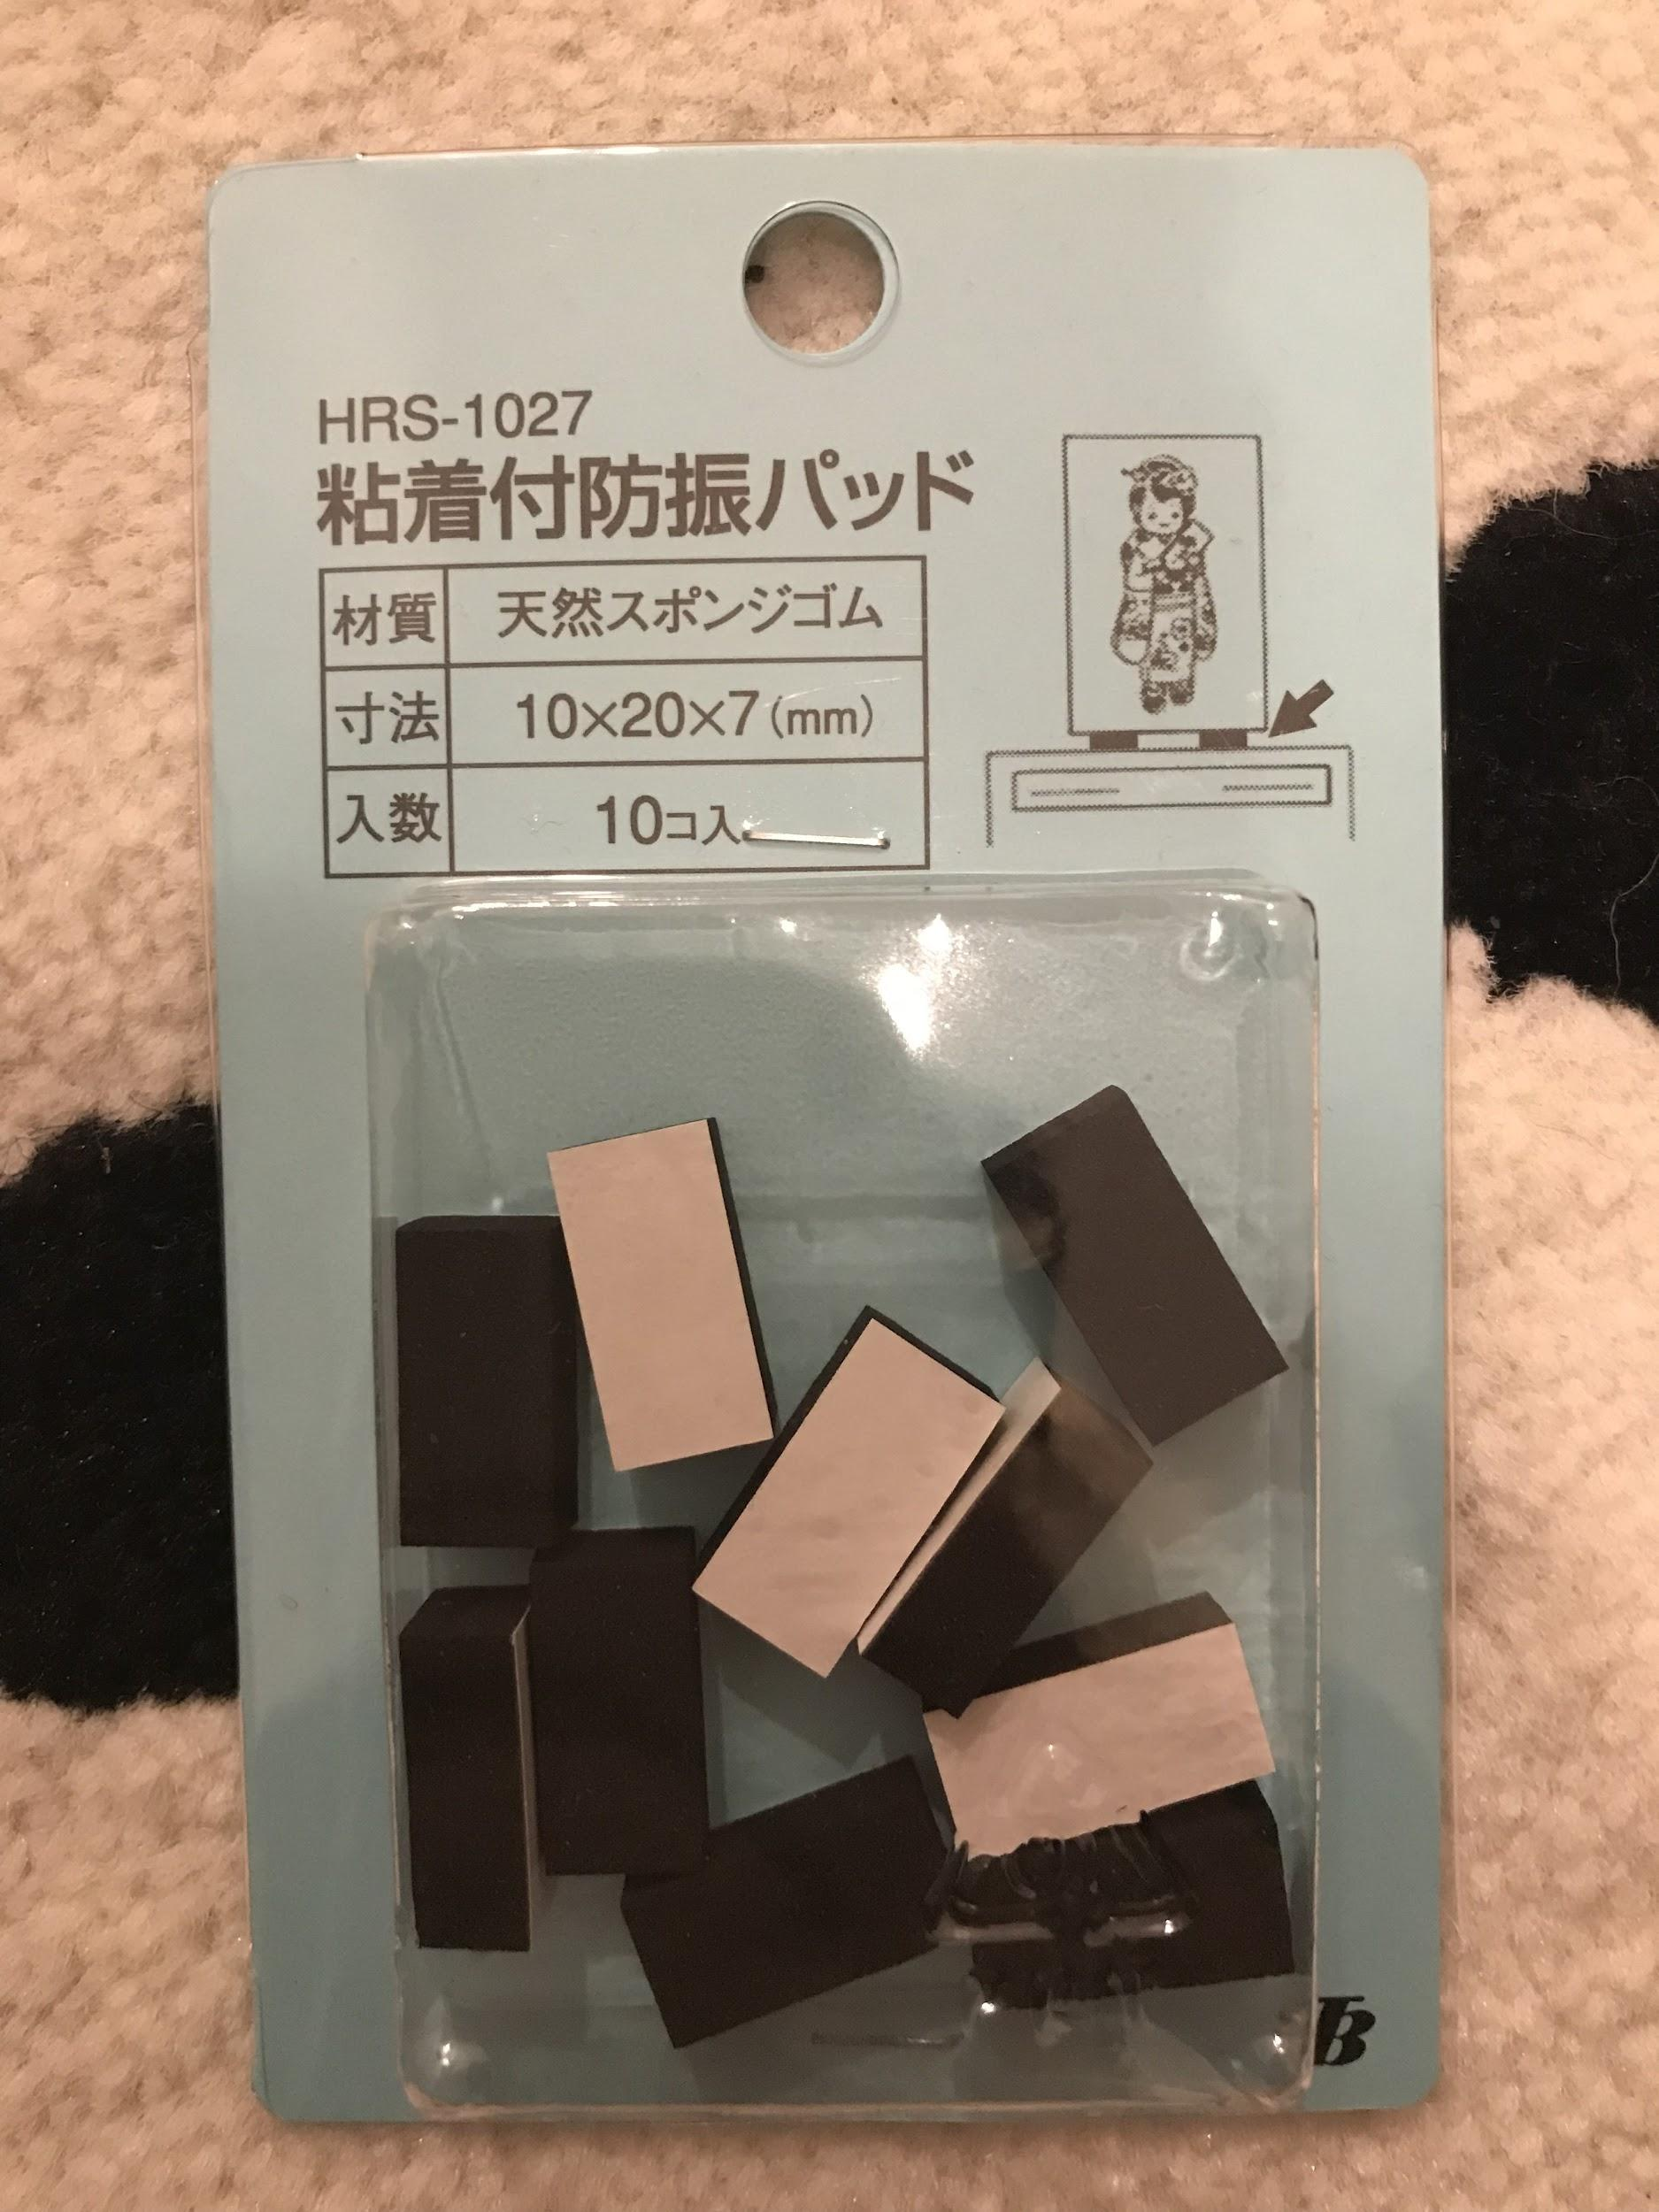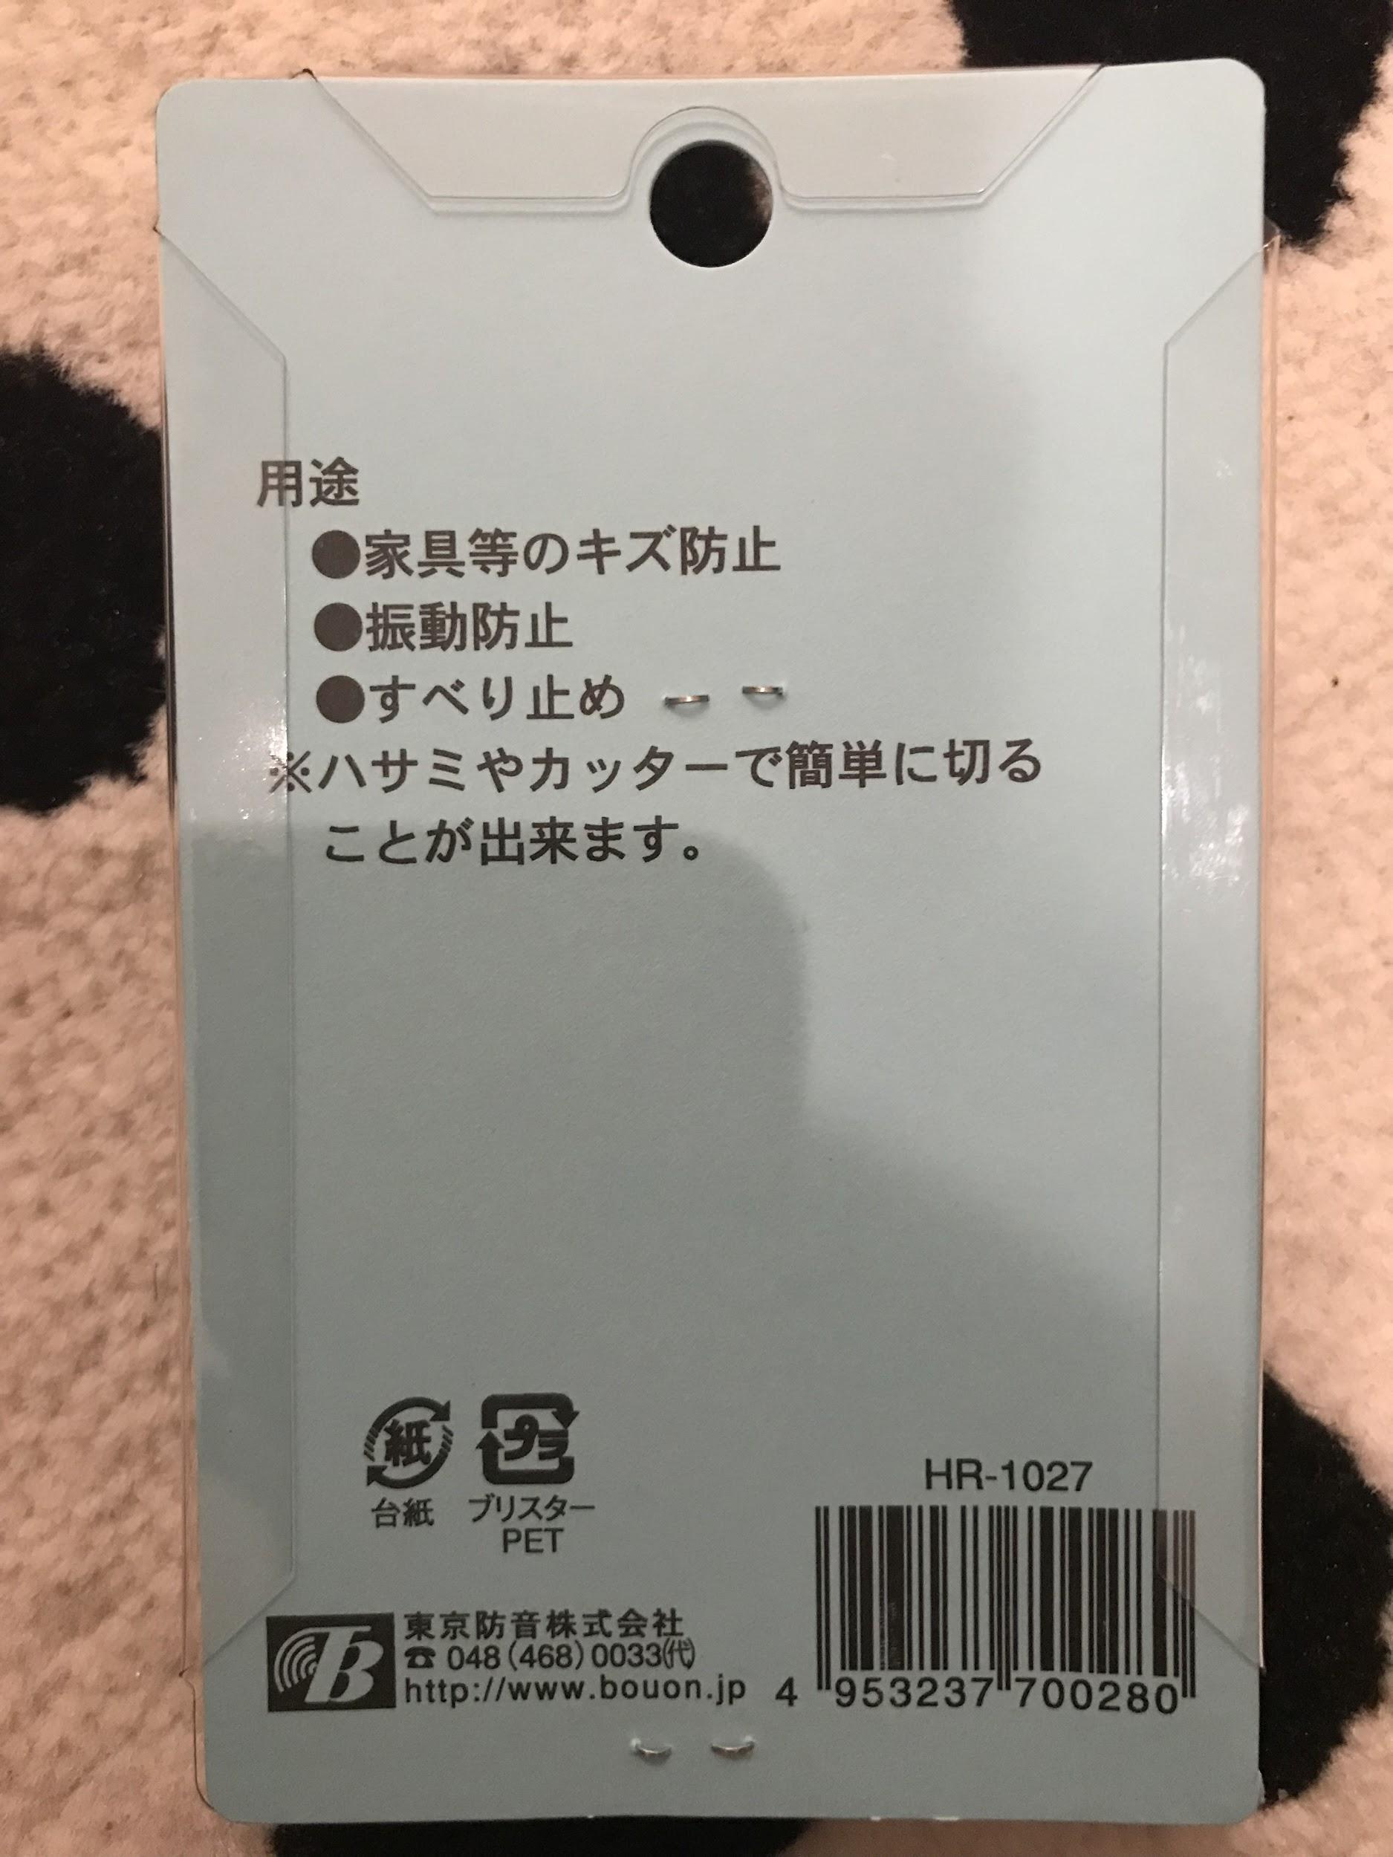

Material #2:

クロロプレーンゴム(Neoprene), 3mm thick - nice neoprene feel, yum

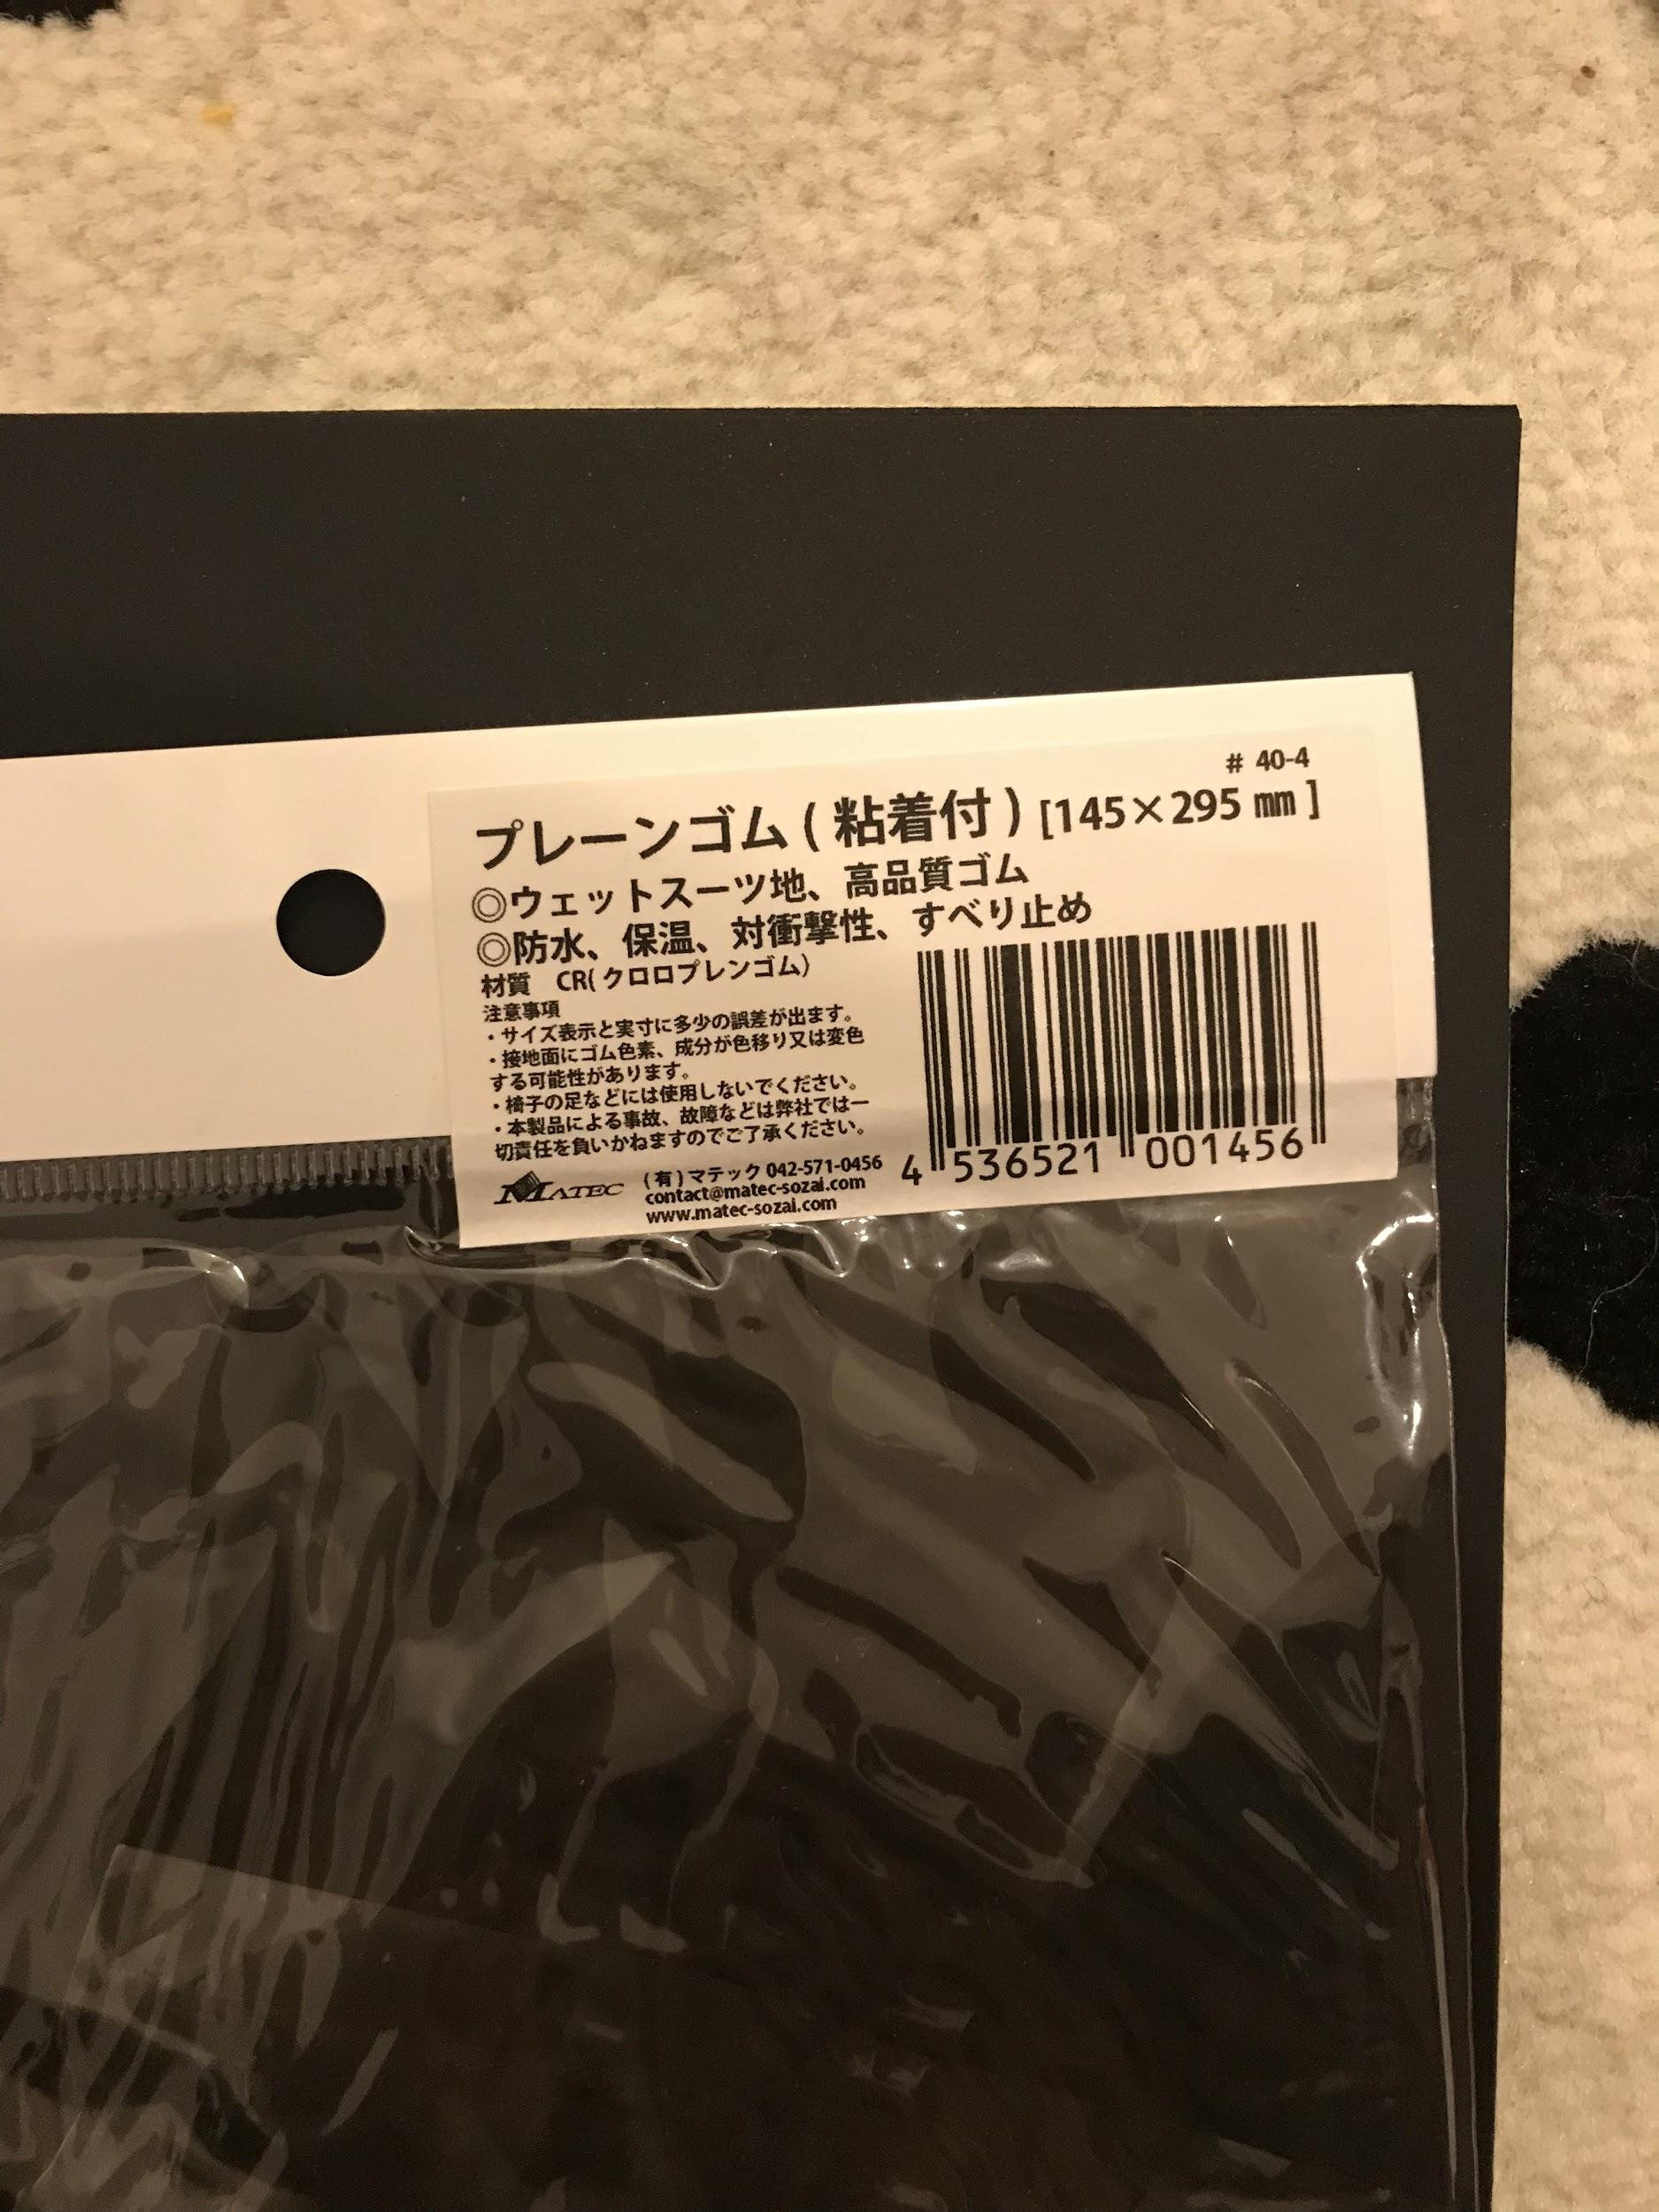

Material #3:

5mm thick, 天然ゴム (natural rubber)

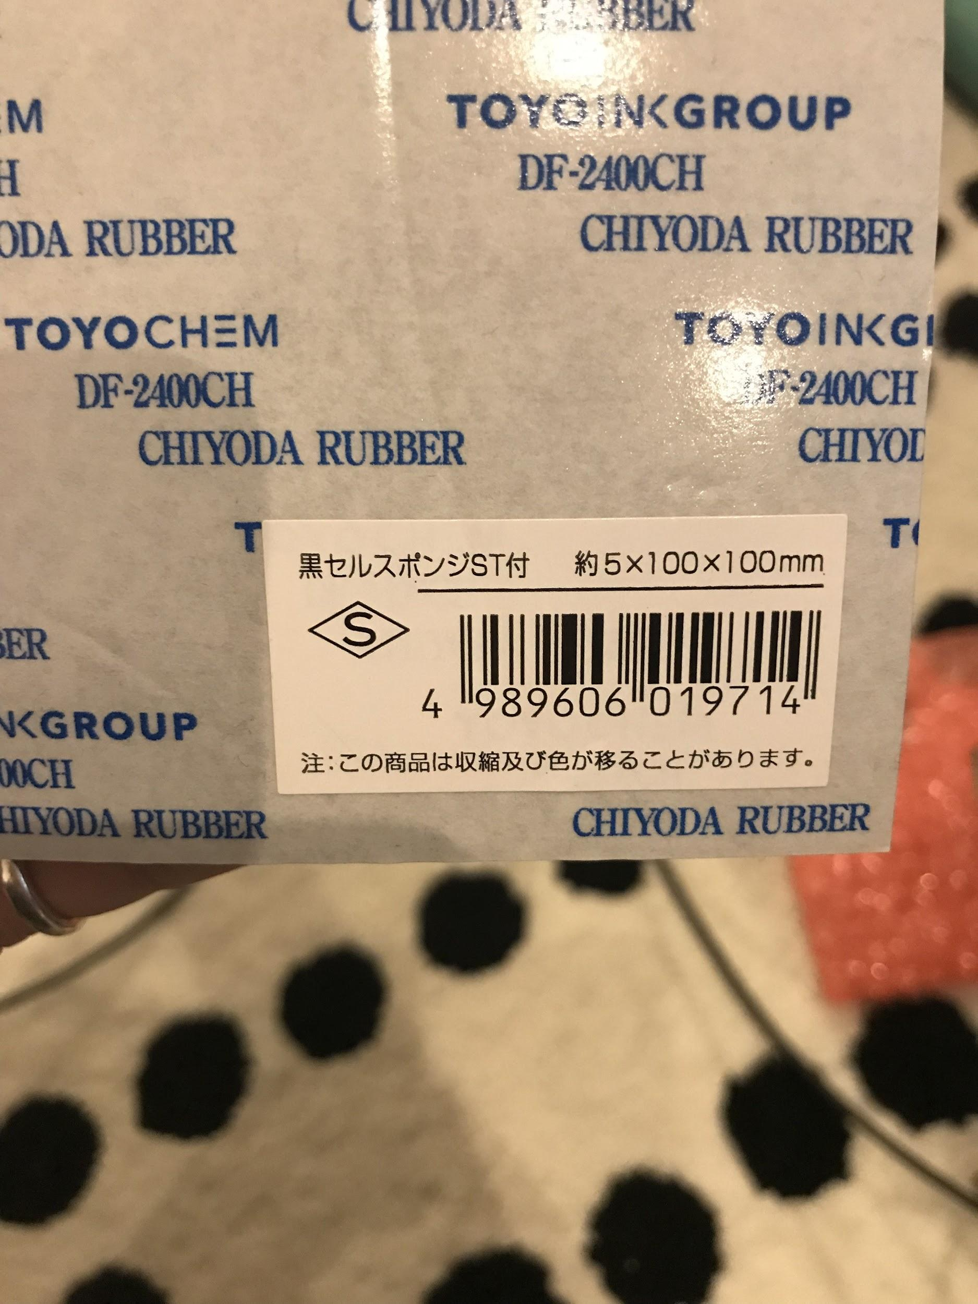

Materials #4 and #5 - neoprene tape, 5mm thick and 2.5mm thick

